Restricted Earth Fault
This document reviews the operating principle of five common relays with respect to the low-impedance REF function. For each relay, the function behavior is first examined in the same manner as described in the relay manual. Then, the method for designing a complete test plan for that function is presented. The relays covered in this document are MiCOM P632, Siemens 7UT6x, Siemens 7UT8x, ABB RET521, and ABB RET620.
In some of the listed relays, relay operation is based on comparing the neutral-branch current with the zero-sequence current calculated by the relay. In practice, the relay operates based on the difference, or differential quantity, between these two currents. In some other relays, however, the comparison of these two currents is used only for relay stability by determining whether the fault is inside or outside the protection zone. In those cases, relay operation is based only on the neutral-branch current, and the differential quantity between the two currents is not used for relay operation.
Restricted Earth Fault (REF) protection is used to detect earth faults inside different equipment such as transformers, autotransformers, reactors, motors, and similar apparatus. Because of its high accuracy and sensitivity, this protection can largely cover the areas that are not fully covered by transformer differential protection and conventional earth-fault protection. REF protection can be applied only when it is possible to measure the current flowing through the neutral point.
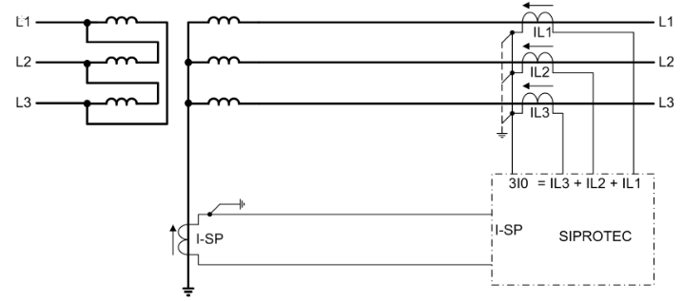
During normal system operation, Isp and 3I0 are approximately zero. As soon as an earth fault occurs, both currents change. Depending on the fault conditions, their values may be equal or may differ from one another.

1-1 MiCOM P632
The ground differential protection of this relay is based on comparing the vector sum of the phase currents on the relevant transformer side with the neutral-point current IY. To begin analyzing the behavior of this function, the relay parameters are first reviewed according to the relay manual. The first parameter used by this relay is the Matching Factor, which is calculated as follows.
Iref,N = Sref / (√3 × Vnom)
Kph = Inom,ph / Iref,N
KY = Inom,Y / Iref,N
Iref,N: reference current of the ground differential protection function
Sref: reference power
Vnom: nominal voltage
Kph: phase matching factor
KY: starpoint matching factor
Inom,ph: primary nominal current of the phase current transformer
Inom,Y: primary nominal current of the current transformer in the starpoint
The following conditions apply to the Matching Factors:
- The Matching Factor must always be less than 16.
- The Matching Factor must always be greater than 0.5.
If the Matching Factor does not satisfy the above conditions, an alarm is issued and the function is blocked.
Two operating modes are described for this relay in the manual. Each mode is reviewed separately below.

1-1-1 Low imped. / sum(IP)
In this mode, the difference between each phase current and the neutral current is calculated as the differential current. The bias current is also considered to be the phase current.
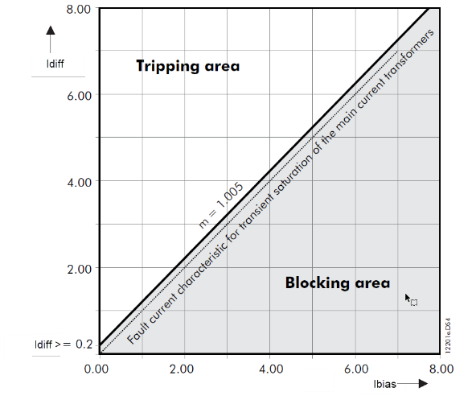
Idiff = |Iph + IY|
Ibias = |Iph|

1-1-2 Low imped. / IP, max
For this operating mode, the differential current and the bias current are defined as follows.
Idiff = |3I0 + IY|
Ibias = (|IP| + |IS|) / 2
3I0 = IA + IB + IC
IY = neutral-point current
Compared with the "Low imped. / Sum (IP)" operating mode, a dual-slope characteristic is used here.
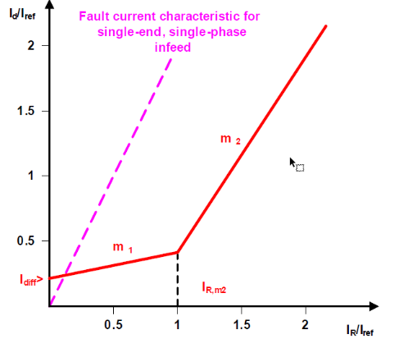

1-1-3 Test Procedure
To test this function, REF must be selected as the Protection Function in the Differential room. In the Primary column, the phase-side information (Main Side) must be entered, and in the Secondary column, the neutral-side information must be entered.
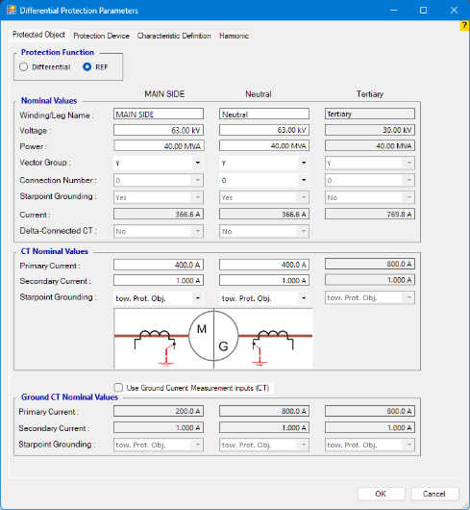
In the Protection Device tab and the Characteristic Definition tab, the information must be entered according to the operating mode selected in the relay.

Low imped. / Sum (IP)
Considering the bias-current formula for this mode, in which the phase current is used as the bias current, the appropriate formula is Max(Ip,Is). By default, the software assumes Ip to be the larger current, which causes the selected formula to match the relay formula. Since the REF characteristic-curve data are fixed, the information for Idiff>, Idiff>>, and the Characteristic Definition tab can be entered as shown below. In this mode, the information in the relay settings does not affect the characteristic curve.
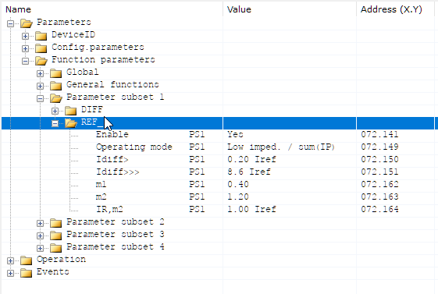
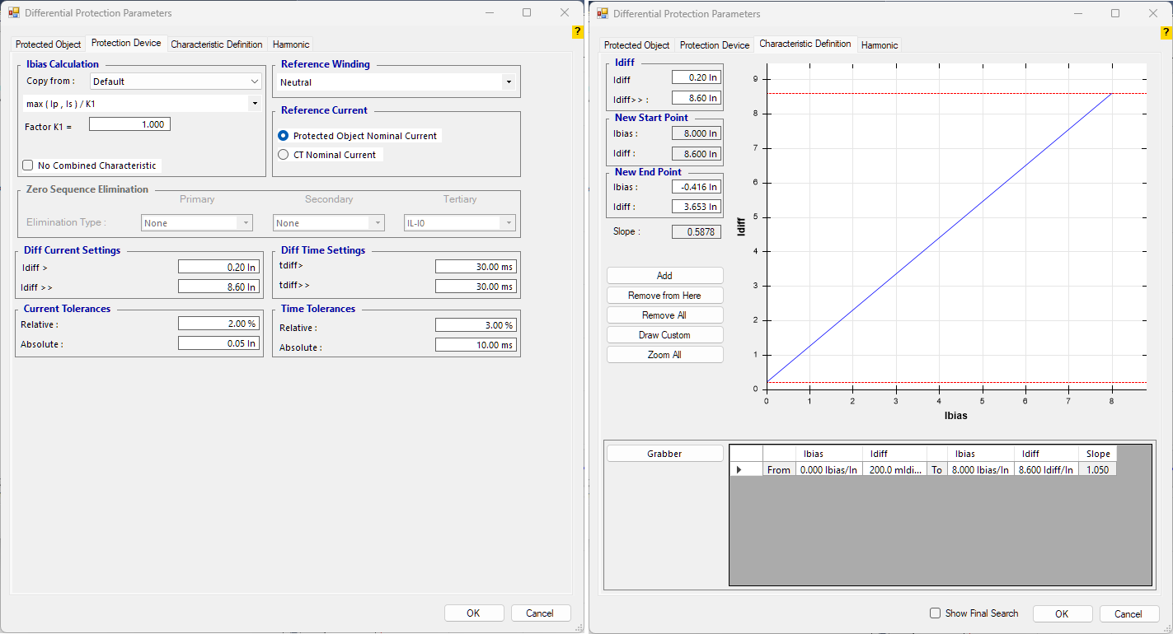

Low imped. / Ip,max
In this mode, the selected bias-current formula is (|IP| + |IS|) / 2. This is because, for each single-phase Fault Type, the tester injects current from only one phase on each side; therefore, Ip = 3I0. For the characteristic-curve data, the relay settings must be checked and the relay characteristic curve must be completed accordingly.
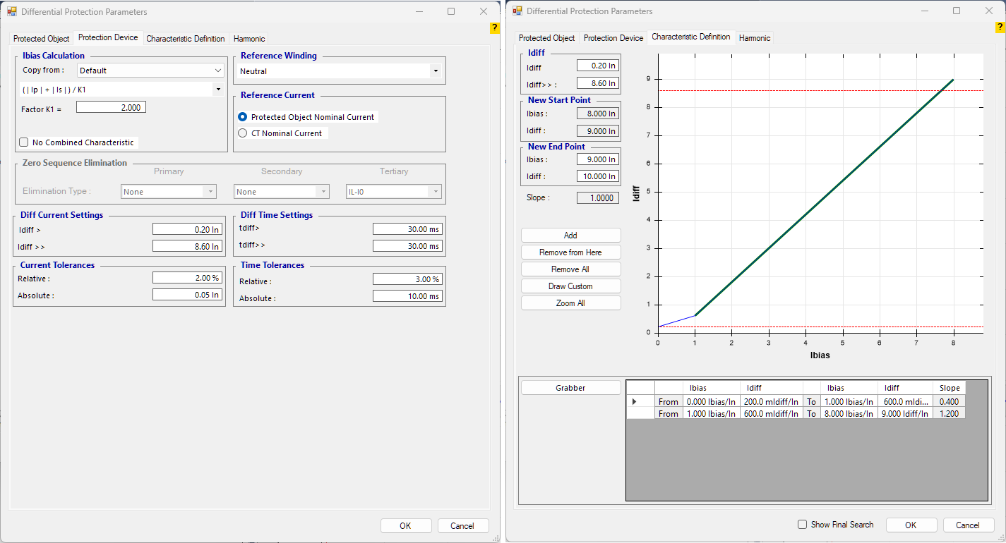

1-2 Siemens 7UT6x (SIPROTEC 4)
As mentioned earlier, REF protection uses two currents, Isp and 3I0, to perform the protection process. In this process, the only operate current is Isp, while 3I0 is used to determine whether the system fault is internal or external. During normal system operation, Isp and 3I0 are approximately zero. As soon as an earth fault occurs, both currents change. Depending on the fault conditions, they may be equal or may differ from one another.
- If the fault occurs inside the protection zone, both Isp and 3I0 will flow. Considering that the directions of these currents are toward the inside of the transformer, both currents are considered positive.
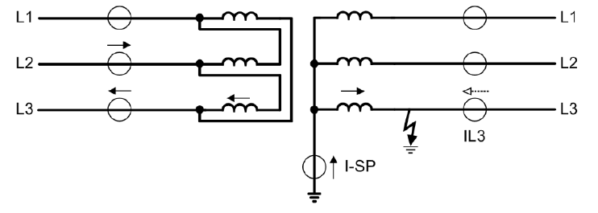
- If the fault occurs outside the protection zone, both Isp and 3I0 will flow. Isp flows toward the inside of the transformer and is considered positive, whereas 3I0 flows out of the transformer and is considered negative.
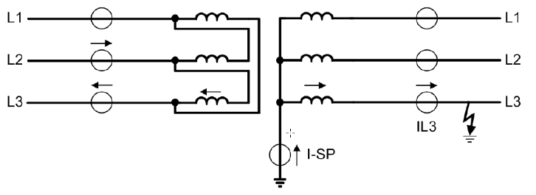
To prevent REF protection from producing a false operation for faults outside the protection zone, a stabilizing method must be defined for the relay in addition to defining an operate current. Based on this explanation, IREF and Istab are defined as follows.
IREF = |Isp|
Istab = |Isp - 3I0| - |Isp + 3I0|
To clarify the concept, three different fault conditions are described below.
- External-zone fault with equal magnitudes of Isp and 3I0
In this condition, assuming equal magnitudes for Isp and 3I0, the direction of Isp is toward the inside of the transformer and is considered positive, while the direction of 3I0 is out of the transformer and is considered negative.
3I0 = -Isp
IREF = |Isp|
Istab = |Isp - 3I0| - |Isp + 3I0| = |Isp + Isp| - |Isp - Isp| = 2Isp
In this condition, the stabilizing current is twice the operate current, and REF protection remains stable.
- Internal-zone fault with the fault fed only from the star point
In this condition, Isp is toward the inside of the transformer and positive, while 3I0 is zero.
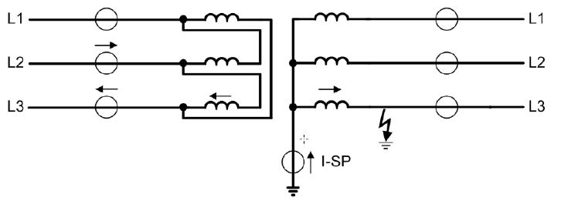
3I0 = 0
IREF = |Isp|
Istab = |Isp - 0| - |Isp + 0| = 0
In this condition, REF protection is at its highest sensitivity and will trip.
- Internal-zone fault with the fault fed equally from the star point and the system
In this condition, the directions of Isp and 3I0 are both toward the inside of the transformer and are considered positive.
3I0 = Isp
IREF = |Isp|
Istab = |Isp - 3I0| - |Isp + 3I0| = 0 - 2Isp = -2Isp
In this condition, Istab is negative. Therefore, it is set to zero, and REF protection operates at its highest sensitivity and will trip.
According to the explanations above, for an internal-zone fault the relay has no stabilizing current and will trip. For an external-zone fault, however, a large stabilizing current exists and the relay will not trip. The operating characteristic of this protection in the Siemens relay for different values of Isp and 3I0 is shown below.
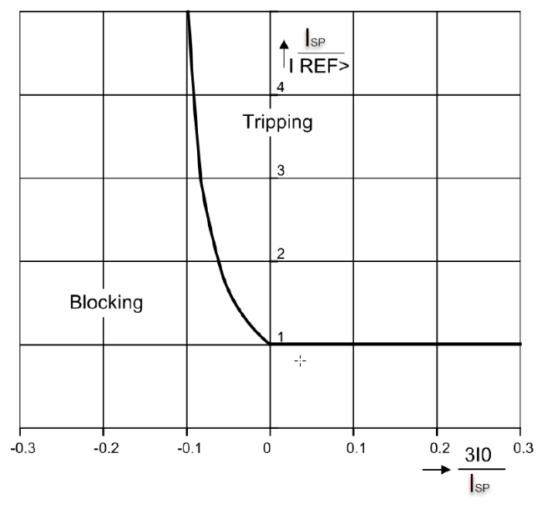
In all the examples above, it was assumed that the directions of Isp and 3I0 are either the same or have a 180-degree angular difference. This assumption is valid for primary quantities. However, for secondary quantities, conditions such as CT saturation and angle measurement errors may create angular deviations and reduce the value of ISTAB. Based on the method described above, assuming equal magnitudes for Isp and 3I0, if the angle between Isp and 3I0 is 90 degrees, the value of ISTAB becomes zero.
Example:
In the Siemens relay, a parameter called Limit Angle is defined, and its value is 100 degrees. If the angle between Isp and 3I0 is greater than this value, the relay will remain stable. The REF operating characteristic based on the angle between Isp and 3I0 is shown below.
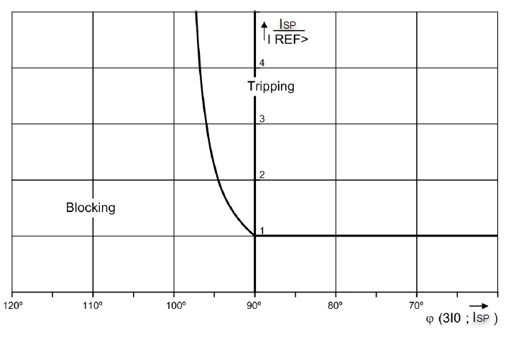

1-1-4 Test Procedure
Because the REF function in Siemens SIPROTEC 4 relays is not designed as a differential function and no differential characteristic curve is defined for it, it cannot be tested in the Differential room. It must be tested in the AMT Sequencer room. For this purpose, one current from group A and one current from group B must be activated in the Hardware Config. Current IA is connected to the phase side, and current IB is connected to the neutral side.
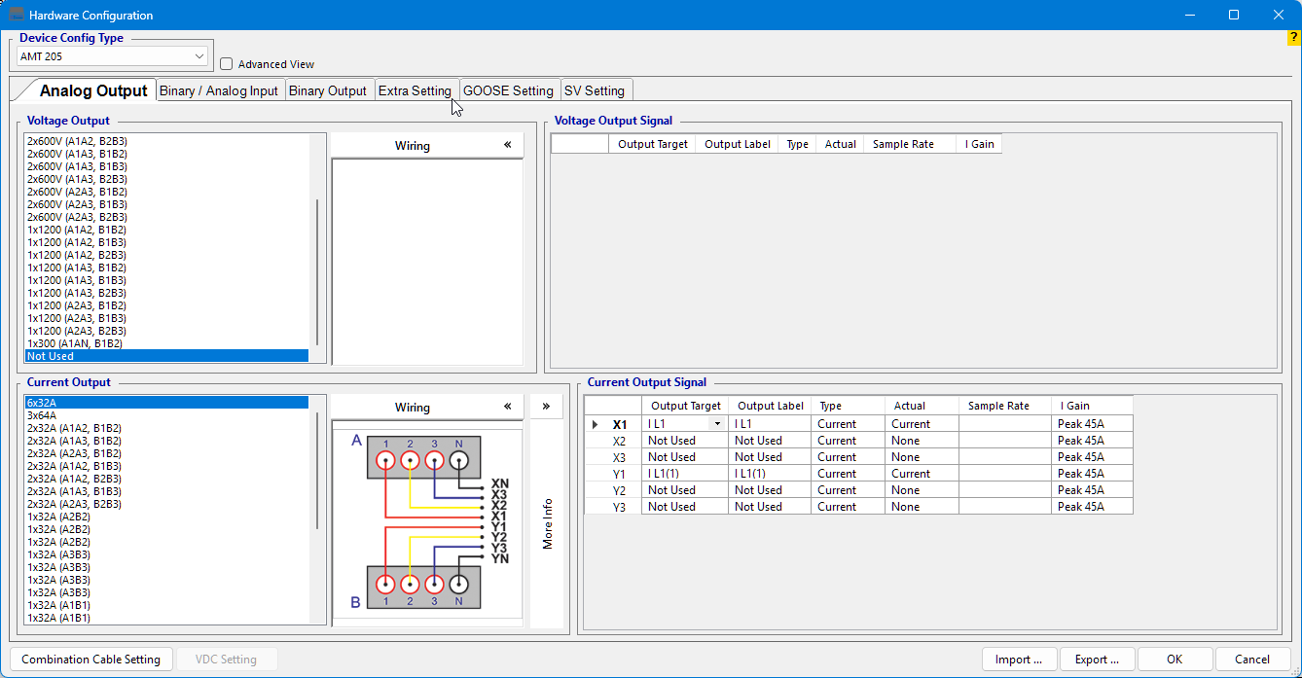
In the first test step, the Setting value must be tested. For example, for a value of 0.15In, current must be injected only from the neutral side using a Step Ramp, increasing the current in 2.5 mA steps. Note that in this relay, In is considered based on the transformer rated current, not the CT rated current. For example, if the rated current on the HV side is 250 A and the CT used is 300/1, then with the 0.15In setting the intended value is 0.15 × 250 = 37.5 A on the primary side and 0.125 A on the secondary side.
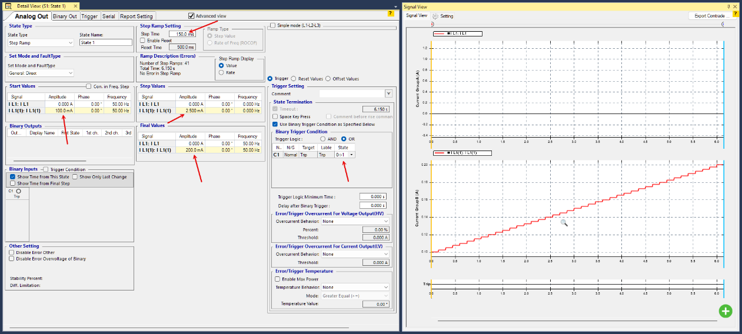
In the next test step, the stabilizing method and the angle between the neutral current and the phase current must be tested. To test the stabilizing method, the phase current must be injected with the same magnitude as the neutral current. In the first case, it must be in phase with the neutral current; in the second case, it must have a 180-degree angular difference. In the in-phase condition, the relay trips, while in the 180-degree condition the relay must remain stable.
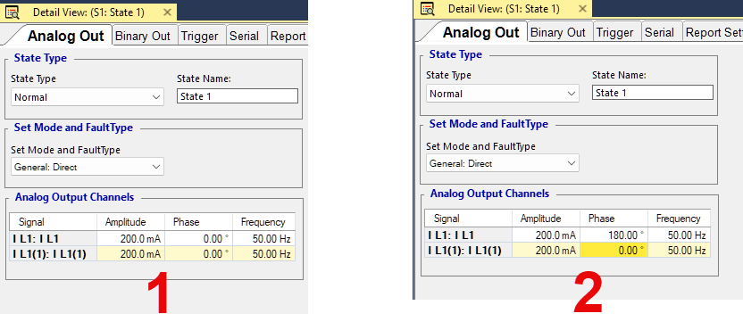
In the final step, the Limit Angle, whose value is 100 degrees, must be tested. To do this, it is sufficient to select Quick mode and manually change the angle so that the relay behavior dependent on this angle can be tested and verified.
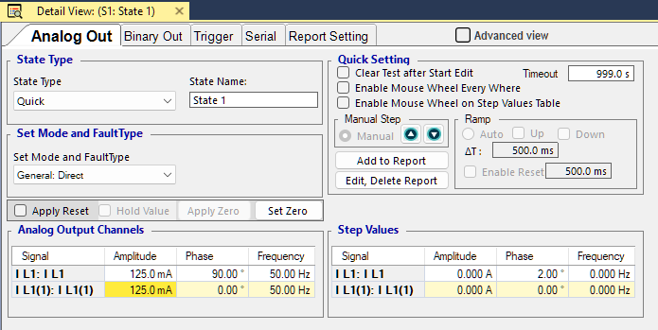

1-3 Siemens 7UT8x (SIPROTEC 5)
This relay uses IY, which is the neutral current, and 3I0, which is the zero-sequence current, for its calculations. From these two parameters, a differential current and a bias current are calculated.
Idiff = |IY + 3I0|
Ibias = |IY| + |IA| + |IB| + |IC|
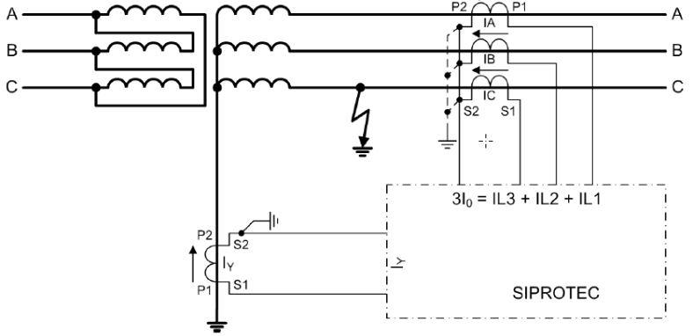
The characteristic curve provided for this function is in the form of Ichar versus Ibias. Ichar has separate definitions for pickup and trip, and therefore REF pickup operation and REF trip operation must be analyzed separately.
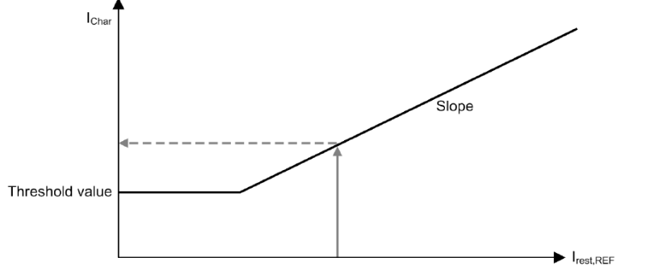

Trip Operation
For relay trip, the ratio of the neutral current to the Ichar value corresponding to Ibias on the characteristic curve is evaluated.
Itrip = |IY| / |Ichar|
According to the information provided in the relay manual, in order for the relay to issue a trip, the value of Itrip must first be greater than 1. In addition, relay trip depends on the angle between the neutral current and 3I0. If this angle is less than 90 degrees, the fault is considered internal. If it is greater than 90 degrees, the fault is identified as either internal or external depending on the ratio of IY to 3I0.
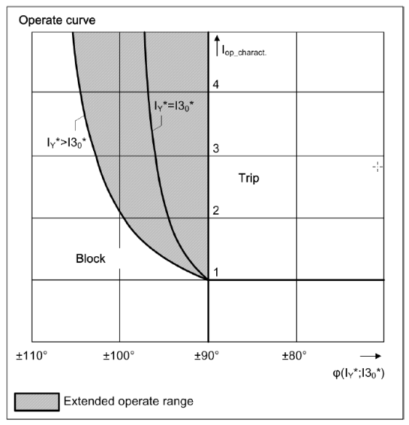

Pickup Operation
The pickup of this function is independent of the angle between the currents. If the calculated Idiff is greater than Ichar, the relay will pick up.

1-1-5 Test Procedure
Since the REF trip characteristic curve in Siemens SIPROTEC 5 relays is not treated as a differential characteristic curve, relay trip cannot be tested in the Differential room. The trip test must be performed in the AMT Sequencer room. Note that the characteristic curve has bias on the horizontal axis and Ichar on the vertical axis. For relay trip, this vertical axis represents IY; therefore, relay trip cannot be tested in the Differential room.
For testing in the Sequencer room, three currents from group A and one current from group B must be activated in the Hardware Config. The three group-A currents are connected to the phase side, and current IB is connected to the neutral side.
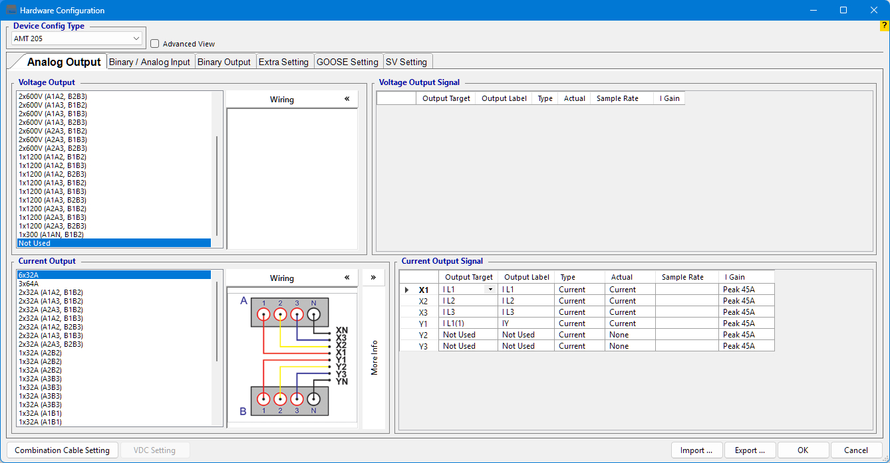
In the first test step, the Setting value must be tested. To do this, current must be injected into one of the three phases, and then the neutral current must be increased step by step. After the relay trips, the neutral current that caused the trip must be matched with the characteristic curve. For this matching, the corresponding bias current must first be calculated using the provided equation, and then IY must be compared with Ichar.
Ibias = |IY| + |IA|
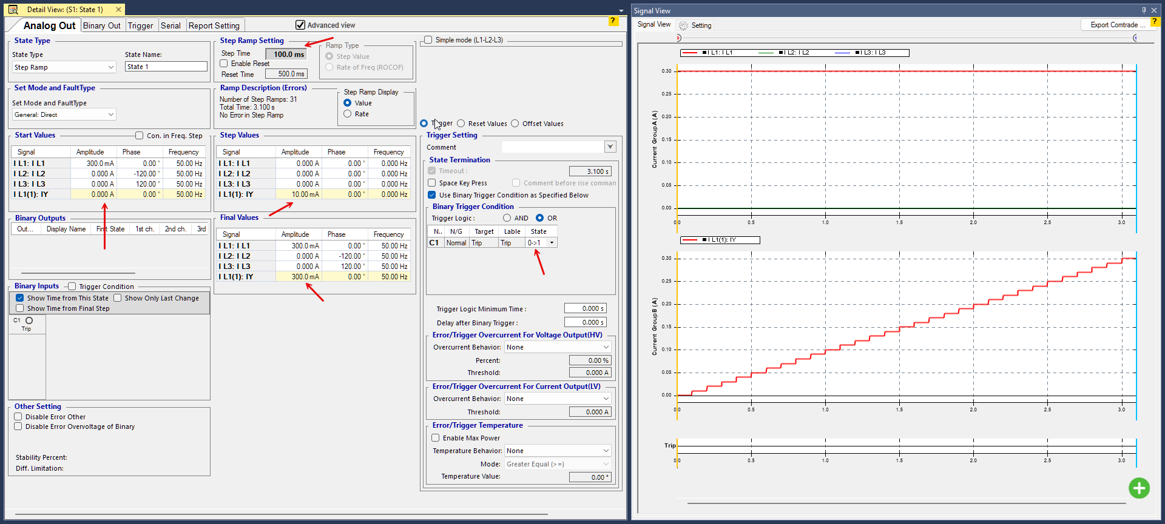
In the next test step, the stabilizing method and the angle between the neutral current and the phase current must be tested. To test the stabilizing method, the phase current must be injected with a specified magnitude, and the neutral current must also be injected under different conditions.
For this purpose, current must be injected into both the phase side and the neutral side and adjusted so that the IY current lies in the operating area of the relay characteristic curve. To test this condition, the current magnitudes must be kept constant in Quick mode, and the angle must be checked at the threshold value, for example 90 degrees, to verify correct relay operation. As shown in the curve on the right, the angle threshold varies depending on the ratio of IY to 3I0, which can be considered during testing.
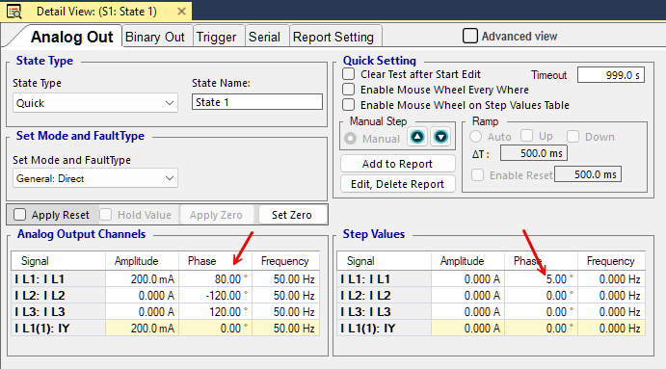
For testing relay pickup, the Differential room can be used because, according to the relay manual, the vertical axis of the Ichar-Ibias characteristic curve is the differential quantity between the neutral current and the zero-sequence current.
Idiff = |IY + 3I0|
Ibias = |IY| + |IA| + |IB| + |IC|
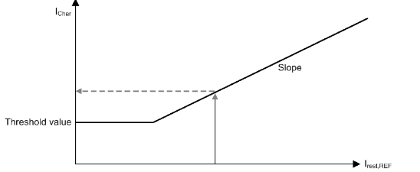
For testing in the Differential room, in the Test Object window, the Differential block must be configured by selecting REF as the Protection Function. Then, the Main Side and Neutral information must be completed according to the side on which this function is applied. The Ibias formula must be entered as IP + IS. Since only one phase current is injected during a single-phase fault, this formula corresponds to the relay formula.
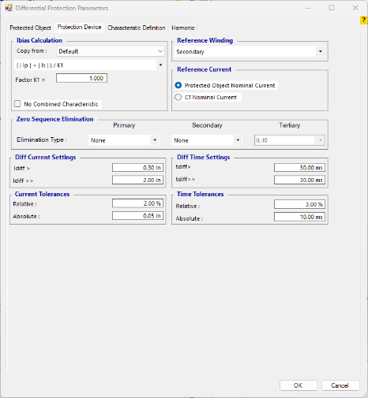
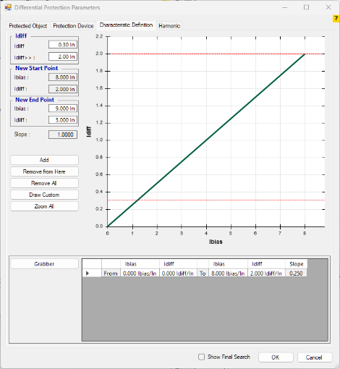
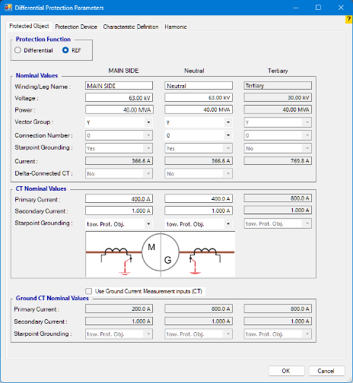

1-4 ABB RET521
To detect an internal-zone earth fault, the relay uses two elements: the diff-bias characteristic curve and a directional element. In this relay, the neutral current (IN) is--- considered the directional reference because its direction is fixed in both internal and external fault conditions. For this relay, the equations given for Idiff and Ibias are as follows.
Idiff = |IN_SEC - IZS_SEC|
Ibias = Max(|IA|, |IB|, |IC|, |IN_SEC|)
Based on the structure provided in this relay manual, the phase-side CTs must be grounded toward the transformer, while the neutral-side CT must be grounded in the opposite direction to the transformer. For this reason, the negative sign in the Idiff calculation becomes meaningful. In general, in order for the relay to identify an earth fault inside the protection zone, the directions of the currents seen by the relay must be opposite to each other.
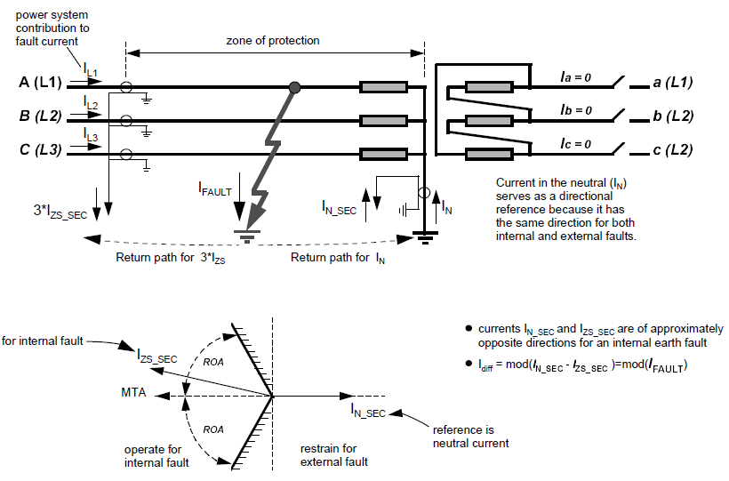
For an internal fault: Idiff = |IN_SEC - IZS_SEC| = |IFAULT|
For faults outside the protection zone, the differential quantity is approximately zero. Based on the relay definition, the direction of the current in both CTs is the same, which causes the relay to identify the fault as being outside the protection zone.
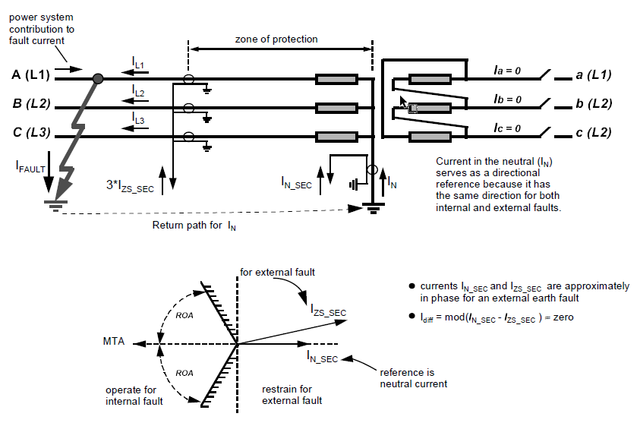
For an external fault: Idiff = |IN_SEC - IZS_SEC| ≈ 0
The diff-bias characteristic curve provided by the relay consists of three sections. In the first section, the threshold current is adjustable by the user from 5% to 50%, while the other sections are defined and fixed.
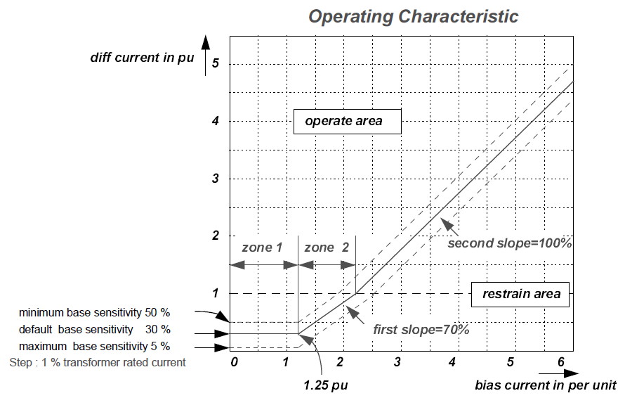

1-1-6 Test Procedure
This function in the RET521 relay can be tested in the Differential room. The following points must be considered when entering the information for this protection function.
To test this function, REF must be selected as the Protection Function in the Differential room. The phase-side information (Main Side) must be entered in the Primary column, and the neutral-side information must be entered in the Secondary column. The Starpoint Grounding direction for the Neutral side must be selected as Toward Line, and the Ibias relation must be selected as Max(Ip,Is). In this example, the differential characteristic curve has been drawn for an operating threshold of 0.3.
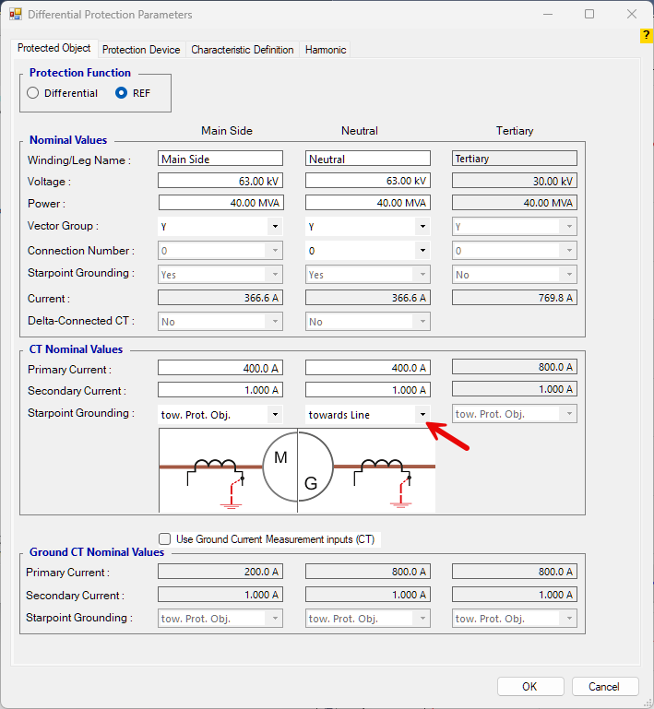
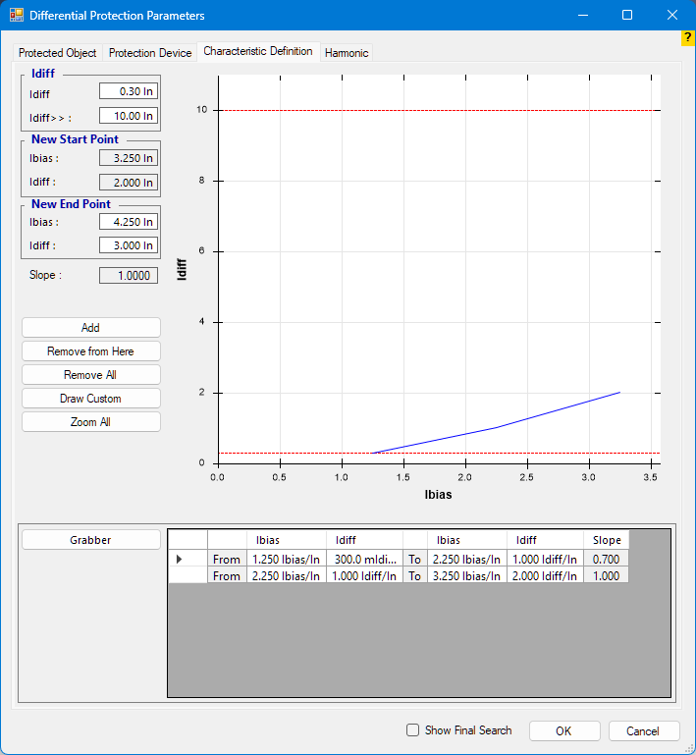
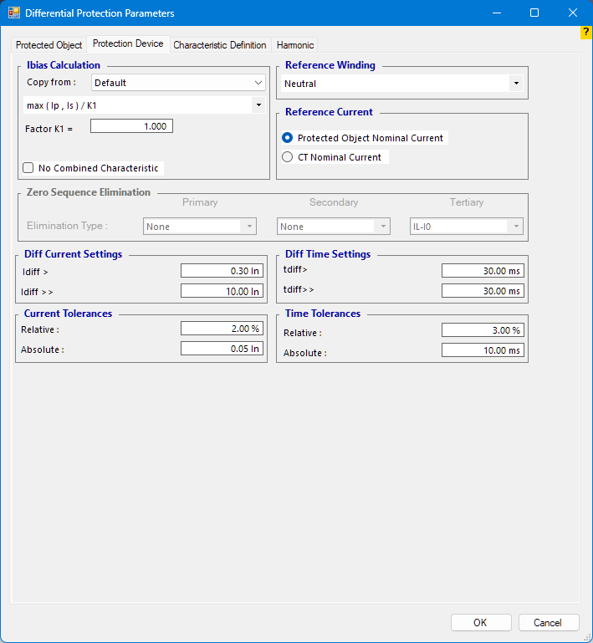

1-5 ABB RET620
For REF protection, this relay uses the differential quantity between the phase zero-sequence current (3I0) and the neutral current IY. A bias current is also defined for the diff-bias characteristic curve of this function, which is the average of the three phase currents of the relay.
ID_COSPHI = (ΣI - IY) × COSφ
IB = (IA + IB + IC) / 3
According to the points stated in the relay manual, COSphi is considered equal to 1 when the angle between the neutral current (IY) and the phase zero-sequence current (3I0) is 180 degrees. If the angle between them is less than 90 degrees, COSphi is considered zero. Therefore, the relay will trip only when the angle between the neutral current (IY) and the phase zero-sequence current (3I0) is greater than 90 degrees.
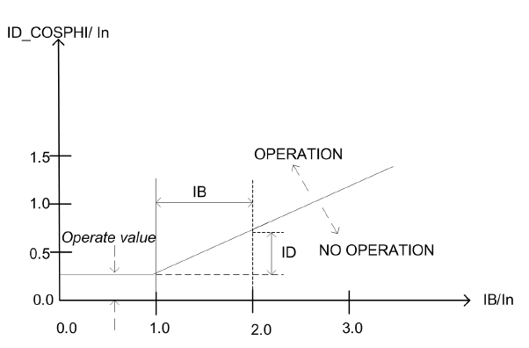
Two Connection Types are defined for this relay. In summary, if the CTs on both sides are grounded either toward the equipment or away from the equipment, the connection is Type 1. If one CT is grounded toward the transformer and the other is grounded in the opposite direction, the connection is Type 2.

Internal and External Fault Identification
In the relay manual, the structure below (Type 1) is used to explain internal and external faults and to analyze relay behavior. In this structure, if the angle between 3I0 and IY is less than 90 degrees, the fault is identified as external and the function is blocked.
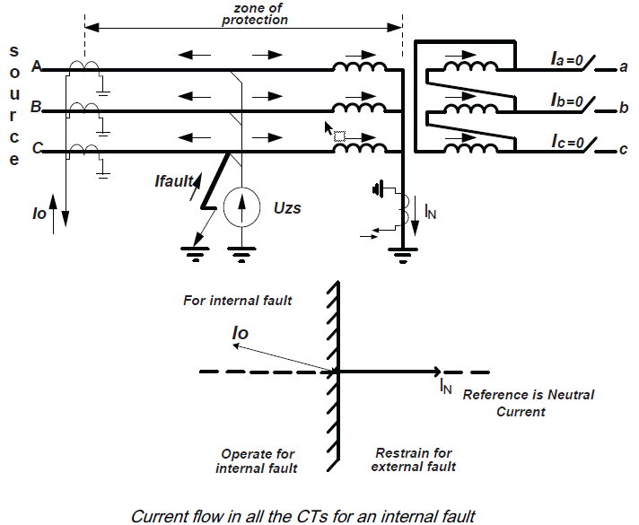
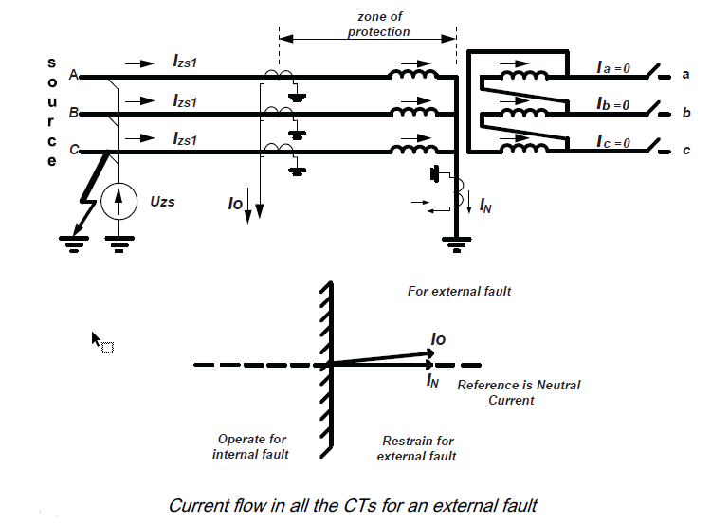

1-1-7 Test Procedure
This function in the RET620 relay can be tested in the Differential room. The following points must be considered when entering the information for this protection function.
To test this function, REF must be selected as the Protection Function in the Differential room. In the Primary column, the phase-side information (Main Side) must be entered, and in the Secondary column, the neutral-side information must be entered. If the Connection Type in the relay is Type 1, the Starpoint Grounding direction of both CTs must be selected as Toward Object; otherwise, the neutral-side CT must be selected as Toward Line.
The Ibias relation must be selected as Max(Ip,Is) / K1, with K1 = 3.
In this example, the differential characteristic curve has been drawn for an operating threshold of 0.3.
